Dr U V Arivazhagu, M.E Ph.D.,
Principal

TO WHOMSOEVER IT MAY CONCERN
This is to certify that the Average percentage of seats filled against seats reserved for various categories (SC, ST, OBC, Divyangjan, etc.) as per applicable reservation policy of Government of Tamil Nadu during academic year 2022-2023 was 364 seats. But the actual number of seats admitted was found to be 387.The difference was due to admissions of reserved category students under the general quota in the academic year 2022-2023 and hence can be justified as 100%.

PRINCIPAL

Dr. U.V. Arivazhagu, M.E., Ph.D.
Principal

TO WHOMSOEVER IT MAY CONCERN

I Would Like to bring to your kind attention that the regular practice of Anna University Chennai in publishing the results of final year/final semester are received only in soft copy formal by the concerned institution through Anna University Chennai portal or through mail addressed to the college examination cell. It does not bear the signature of the controller of examination,

PRINCIPAL

ANNA UNIVERSITY GRADE DETAILS – R2017

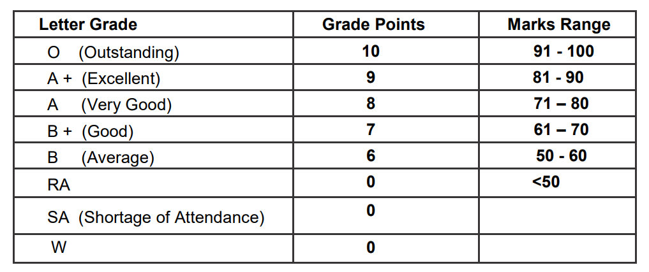
All assessments of a course will be evaluated on absolute marks basis. However, for the purpose of reporting the performance of a candidate, letter grades, each carrying certain number of points, will be awarded as per the range of total marks (out of 100) obtained by the candidate in each subject as detailed below:
A student is deemed to have passed and acquired the corresponding credits in a particular course if he/she obtains any one of the following grades: “O”, “A+”, “A”, “B+”,“B”. ‘SA’ denotes shortage of attendance (as per clause 7.3) and hence prevention from writing the end semester examinations. ‘SA’ will appear only in the result sheet. “RA” denotes that the student has failed to pass in that course. “W” denotes withdrawal from the exam for the particular course. The grades RA and W will figure both in Marks Sheet as well as in Result Sheet). In both cases the student has to earn Continuous Assessment marks and appear for the End Semester Examinations. If the grade W is given to course, the attendance requirement need not be satisfied. If the grade RA is given to a core theory course, the attendance requirement need not be satisfied, but if the grade RA is given to a Laboratory Course/ Project work / Seminar and any other EEC course, the attendance requirements (vide clause 7) should be satisfied.
PRINCIPAL
ANNA UNIVERSITY GRADE DETAILS – R2013
All assessments of a course will be done on absolute marks basis. However, for the purpose of reporting the performance of a candidate, letter grades, each carrying certain number of points, will be awarded as per the range of total marks (out of 100) obtained by the candidate in each subject as detailed below:
Letter grade Grade Points Marks Range
S 10 91 – 100
A 9 81 – 90
B 8 71 – 80
C 7 61 – 70
D 6 57 – 60
E 5 50 – 56
U 0 < 50
W 0
A student is deemed to have passed and acquired the corresponding credits in a particular course if he/she obtains any one of the following grades: “S”, “A”, “B”, “C”, “D”, “E”. ‘SA’ denotes shortage of attendance and hence prevention from writing the end semester examination. ‘SA’ will appear only in the result sheet. “U” denotes Reappearance (RA) is required for the examination in the course. “W” denotes withdrawal from the exam for the particular course. (The grades U and W will figure both in Marks Sheet as well as in Result Sheet)
PRINCIPAL

